Are you unable to access UoP sites?
When trying to access a UoP site, such as the portal, you are shown a page with the error “You need permission to access this site”

Why am I seeing this?
The most likely reason you are seeing this is because:
- You are using a computer belonging to a partner college and the web browser is trying to log you into a UoP site with your partner college user account.
- You are using a computer belonging to an NHS trust and the web browser is trying to log you into a UoP site with your NHS user account.
- You are using your own computer and the web browser is trying to log you into a UoP site with your personal Microsoft user account.
In some situations, you may not even be given a chance to enter your UoP username and password however this depends on how your computer is configured.

How can I access UoP sites?
If you find yourself in this situation, the simplest way to sign in is to use a “private” web browser session. This means your web browser doesn’t remember the login information from a standard session. Starting a private web browser session varies from browser to browser. Here is how you do it in the most common browsers –

Microsoft Edge
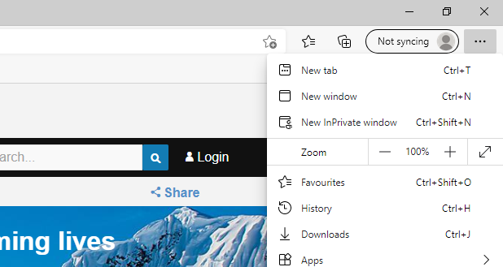 | Open Edge and either  - Press CTRL, Shift and N together on your keyboard  - Go to the menu in the top right corner (▪▪▪) and choose “New InPrivate Window”  You can also right click on the Edge icon in either the Start Menu or Task Bar along the bottom of the screen and choose “New InPrivate Window”  Now use the new window to go to the UoP site you need to access.

FireFox
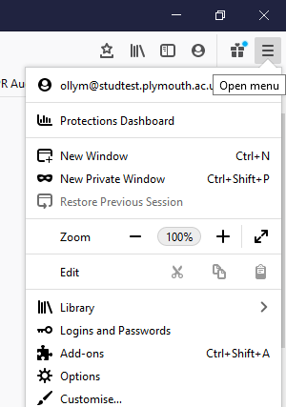 | Open FireFox and either  - Press CTRL, Shift and P together on your keyboard  - Go to the menu in the top right corner () and choose “New Private Window”  You can also right click on the FireFox icon in either the Start Menu or Task Bar along the bottom of the screen and choose “New Private Window”  Now use the new window to go to the UoP site you need to access.

Chrome
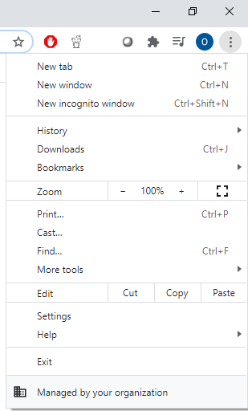 | Open Chrome and either  - Press CTRL, Shift and N together on your keyboard  - Go to the menu in the top right corner () and choose “New incognito window”  You can also right click on the Chrome icon in either the Start Menu or Task Bar along the bottom of the screen and choose “New incognito window”

Safari (on an Apple)
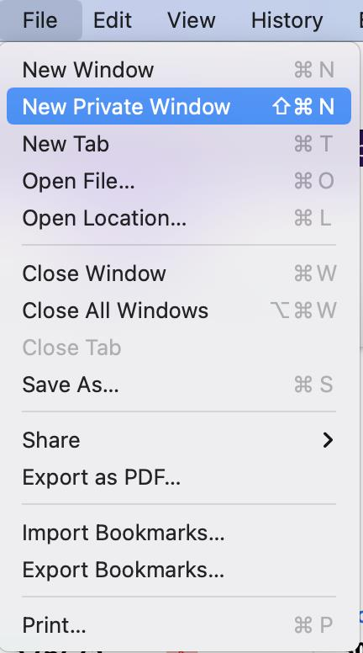 | Open Safari and either  - Press Shift, ⌘ and N together on your keyboard  - Go to the File menu and choose “New Private Window”

